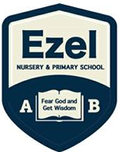 | EZEL NURSERY AND PRIMARY SCHOOL  Home Learning Program  www.ezelschool.com/homelearning.html
Primary Three

Week 1
MONDAY
 | Topics | Activities
Math | - Revise shapes  - Word problems | Activity  1. Draw 3 squares.  2. Draw 2 triangles.  3. Draw 4 circles.  4. Write a set of 5 names in a circle.  5. Write a set of 6 alphabets in a circle
English | - Practice vocabulary  - Arrange words in alphabetical order | - Vocabulary: tap, tank, jerrycan, spring  - Activity: Read and spell the vocabulary words. Find and write the meanings of these words
Literacy | Sight words | To, has , than
Story  (Reading) | Feet, hands and head by Brain Wambi  I use my feet to run, jump, and kick.  I use my hands to eat, work, and hug.  But the head is more important than feet or hands.  The head has the eyes. I see with my eyes.  The head has the nose. I smell with my nose.  The head has the ears. I hear with my ears.  The head has the tongue. I taste salty and sweet.  The head has the mouth.  I speak with my mouth.  The head controls the whole body!
TUESDAY
 | Topics | Activities
Math | - Counting numbers  - Writing number | Activity:  - Count from 100 – 150  - Write number 1 – 20 in words
English | Language practice. | Vocabulary: tap, tank, jerrycan, spring  Activity:  - Read and spell the vocabulary words.  - Make a sentence using each word
Literacy | Say out loud the letters, sounds and words | Letter sound: ch  Syllables of sound ch  Cha , che , chi, cho , chu
Reading | “Feet, hands and head” - Read the story above
WEDNESDAY
 | Topics | Activities
Math | Count numbers, identify numbers and write numbers | - Count from 100 - 150  - Write in words 50 , 51 , 52 , 30 , 12 , 15  - Add 55 and 12
English | Using the word ‘and’ | Examples.  John and peter are boys.  Father and mother are parents.  I like bananas and Tomatoes
Literacy | Drawing | Activity  Draw a tap, tank and jerrycan
Story (reading) | “Feet, hands and head” - Read the story above
THURSDAY
 | Topics | Activities
Math | Count numbers, identify numbers and write numbers | - Count from 100 – 150  - Fill in the missing numbers  100, _____,103 , ______, 105  99, ____, _____, 102
English | Using ‘and’ | Join the sentences using ‘and’  - John has a book.  - John has a pencil  Write 3 more sentences using the word ‘and’
Literacy | Reading and saying sound ‘ch’ | Words beginning with the sound ‘ch’  Church , chat , chalk , chair  Write 3 more words beginning with the sound ‘ch’
Story reading | “Feet, hands and head” - Read the story above
FRIDAY
 | Topics | Activities
Math | Adding numbers | Add the following numbers  - 56+ 12 =  - 77 + 22 =  - 12 + 23 =  - 111 + 111 =
English | -Arrange the words in alphabetical order | Activity: Arrange the words in alphabetical order:  1. ant, rat, cat, bat  2. road, school, market, bridge  3. look, east, along, turn  4. street, road, compass, between  5.direction, alongside, northern, feature
Literacy | Practicing letters, letter sounds | Write the 5 vowel letters.  Write a word for each vowel letter  write letters a - z

Note: Dear parents/caregivers always make sure that
- You explain new words to your child.
- Recite new words as many times as you can
- Be kind and patient with your child, they cannot learn new things in one day.
- Provide your child with books, pencils, crayons and papers.

ACTIVITIES
Activity 1 (Language): Read the story and answer the following questions.
Read the story  ‘The Mad Hen’,  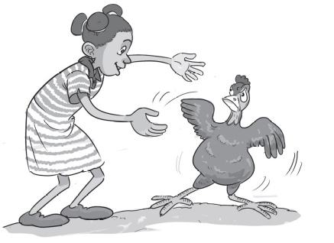 | The red hen was mad. ‘I do not want a hug,’ she said.  A girl ran to the hen. ‘I will give you a hug!’  ‘No,’ said the hen. The hen ran. ‘I am not a pet!’  ‘You are a pet,’ said the girl. ‘I will hug you.’  The girl ran. The hen ran. The girl did not hug the hen.  Answer the questions below.  1. What does the girl want?  2. What happened at the end of the story?  3. How does the hen feel about hugs?  4. What was your favourite part of the story? Why?

Activity 2(Mathematics): Draw the following sets
- A set of 3 trees 4. A set of 2 cups
- A set of 4 balls 5. An empty set
- A set of 6 triangles
Activity 3 (English): Write down the plural of the following words
- Girl –  - Boy –  - Box –  - Sister - | - Brother -  - Baby –  - Chair –  - Knife -

Activity 4(literacy): Draw pictures of the following things
- Table  - Cup  - Chair  - Car | - Hut  - House  - Pot  - tree

Activity 5 (Mathematics): Answer the following additions
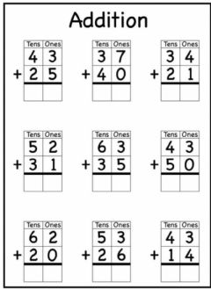

Activity 6 (Literacy): Circle and name all the animals
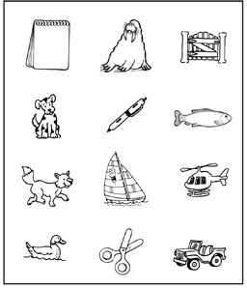
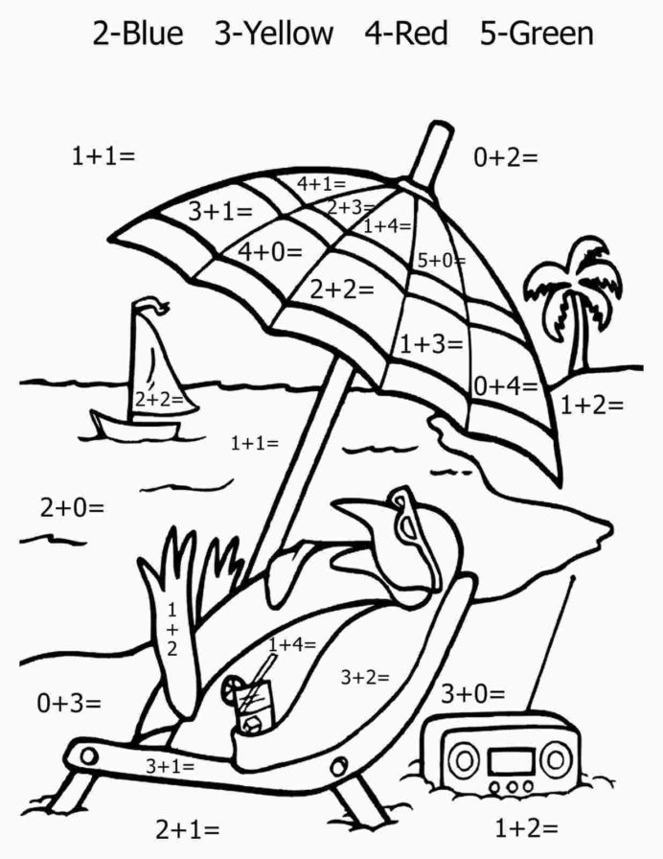
For more information, call
Agule area and all other areas | Kameke Area
0772644523 | 0758650099 | 077074014 | 0786560989 [Director God Help Junior School]

